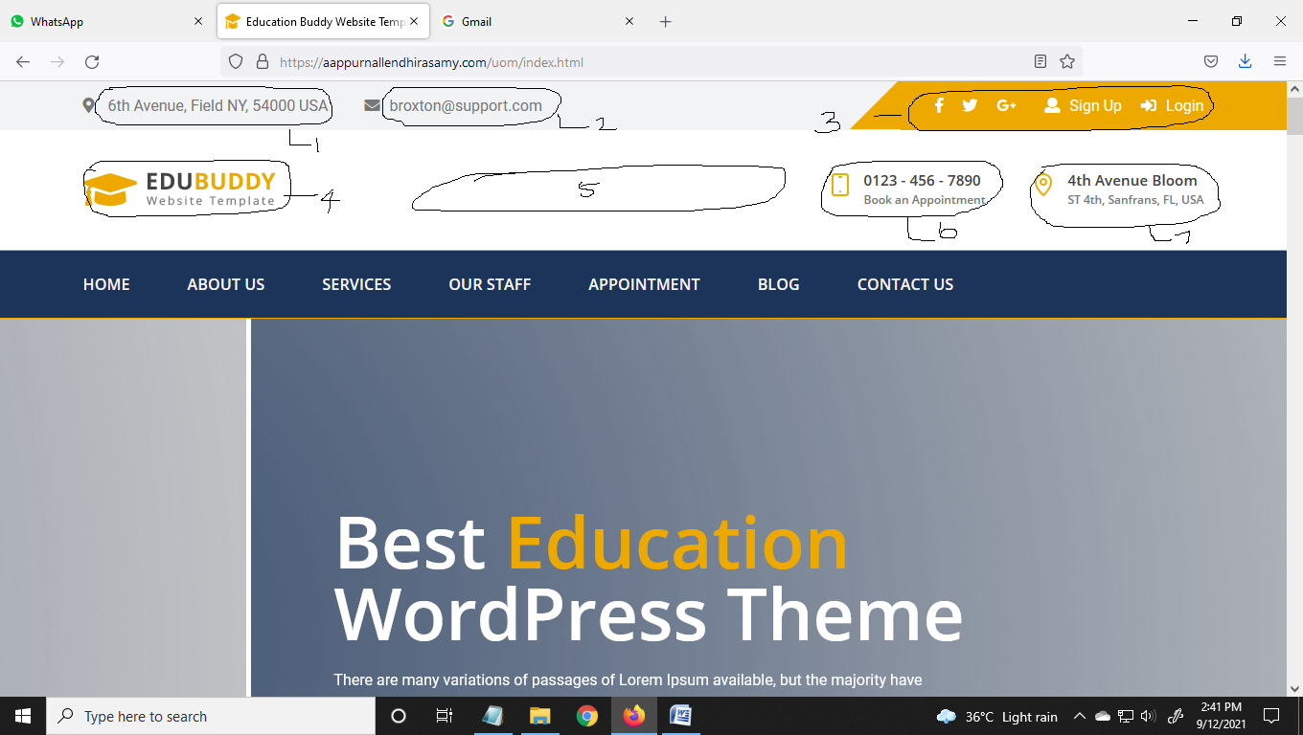

1. Remove and add France & United States of America
2. Remove and add info@uom-edu.fr
3. Remove and add two button as Student Login & Faculty Login

**When we click the Student Login**

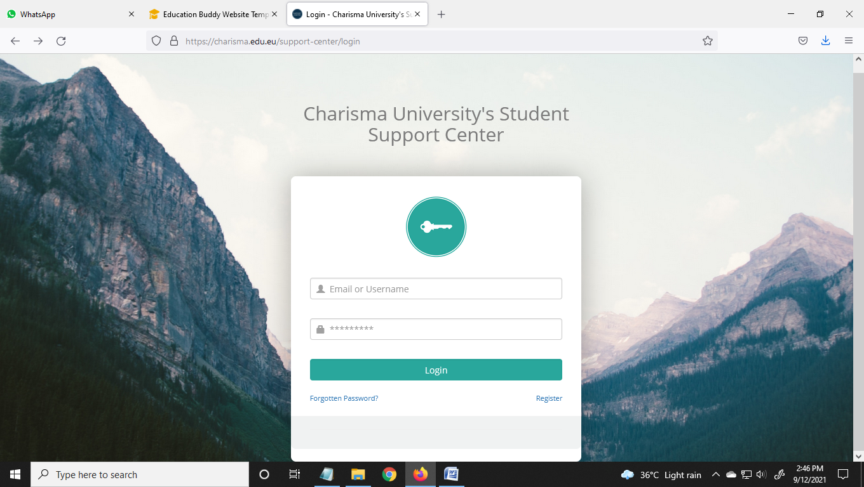

Need this model, in that please mention University of Marlyne – Student Login

**When we click the Faculty Login**



Need this model, in that please mention University of Marlyne – Faculty Login

1. Add our Logo **(Folder 1)**
2. Mention

**UNIVERSITY OF MARLYNE**

1. Remove and add button as Apply Now

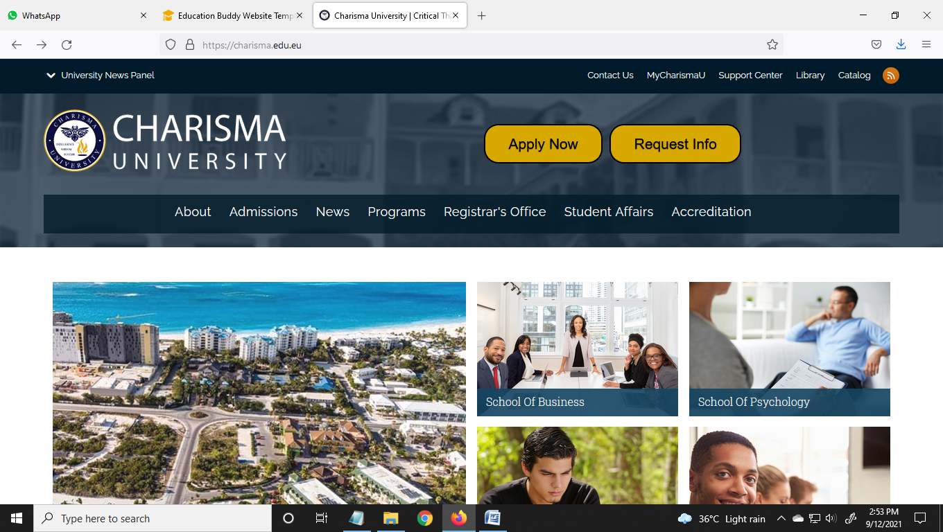

<https://bnuqm-edu.uk/apply-online.php>

Need the same while we click the Apply Now Button

1. Remove and add button as Request Info

<https://cpu-edu.us/online-enquiry.php>

Need the same while we click the Request Info Button

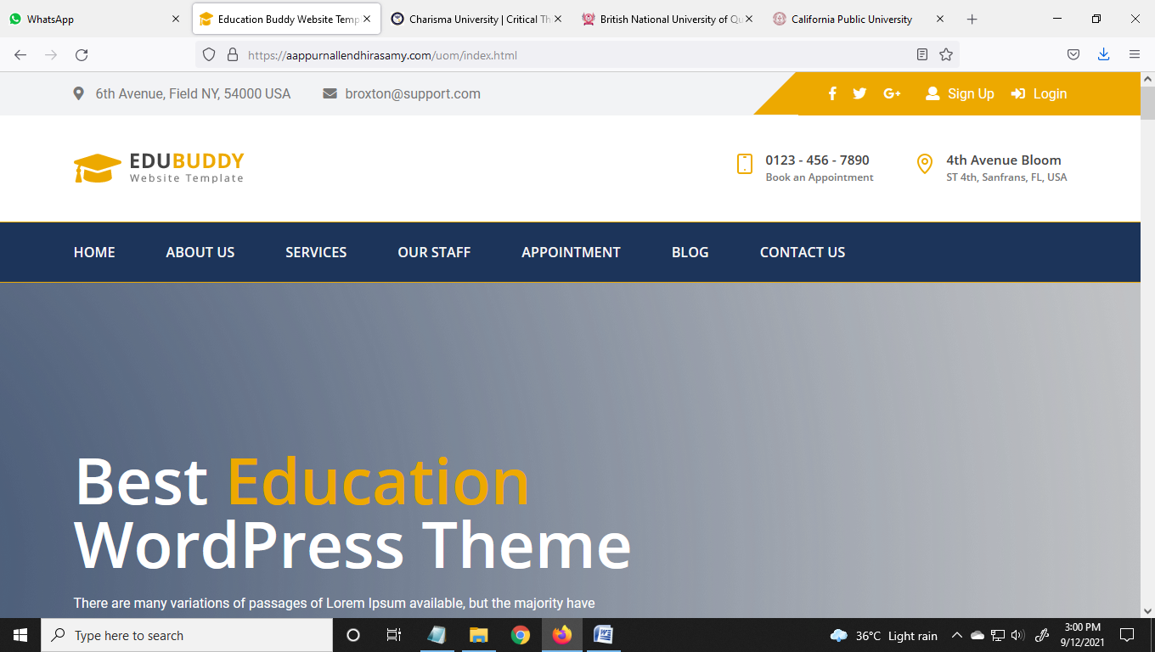

Make the image sliders (Minimum of 5)

<https://aappurnallendhirasamy.com/uom/contact-us.html>

Remove the Google Map

|  |  |
| --- | --- |
| **Online Form**  Name  Email  Phone Number  Subject  Enter Your Message | **Email**  info@uom-edu.fr  office@uom-edu.fr |
| **Address**  Paris, France, European Continent  Delaware, United States of America |
| **Directories**  Faculty / Staff  Administration  Programs |

**Main Menu**

|  |  |  |  |  |  |  |
| --- | --- | --- | --- | --- | --- | --- |
| **Home** | **About Us** | **Admissions** | **Programs** | **Our Team** | **Student Affairs** | **Contact us** |

-------------------------------------------------------------------------------------------------------------

**About Us (Page)**

**Vision:**

University of Marlyne will be a premier center for international students and faculty to gather online, share information, learn from each other, engage in useful scholarship, and improve their lives and communities.

**Mission:**

To make educational excellence accessible and affordable worldwide.

**Goals & Objectives:**

* To prepare graduates (Associate through Doctoral degrees) for competent practices coupled with superior communication skills (both verbal and written).
* To develop graduates with well rounded skill sets so that one’s own practice can be evaluated.
* To present online degree programs that is comprehensive, easy to use, efficient and effective.
* To function within the organizational structures and, if necessary, seek and implement appropriate organizational modifications so that our graduates are recognized as outstanding business leaders and superb educators.
* To pursue courageously innovative educational programs and high value services anchored in truth, established practice and founded science.
* To promote and accelerate leadership as well as encourage professional development through continuing education and intensive curricular formation.
* To facilitate the development of learners towards transformation through a synergistic utilization of current researches, relevant curricular offerings and responsive extension services.
* To relentlessly generate a new breed of self directed, competitive business and educational leaders.
* To support one another, both faculty and students, in sustaining the shared mission.

To achieve these goals, University of Marlyne is committed to provide its students the best and most modern education. Through the use of our innovative online modules, we hope to equip our students and graduates with the latest information and learning in their respective fields. With excellence at the heart of our goals, the university is intent on utilizing and optimizing research in the fields of business, technology, legal studies and education for the advancement of its students, faculty and services. The university will also be responsible for the enhancement of a well rounded, research oriented academe; and thus, encourages research building among its populace. Through faculty members that are highly experienced in diverse fields, the university also plans to produce alumni that are internationally competitive. Additionally, the university aims to develop a network that spans globally to help establish its graduates anywhere in the world.

**University Values:**

In the delivery of all educational opportunities, University of Marlyne affirms the following values.

* Diversity and Inclusion – We embrace the diversity of individuals, ideas, beliefs, and cultures. We respect the dignity of all persons, the rights and property of others, and the right of all people to hold and express disparate beliefs.
* Quality – We strive to deliver education according to world class standards. We are committed to an uncompromising standard of excellence in teaching, learning, creativity, and scholarship. We pursue excellence in all operations and strive to produce the highest quality outcomes in all endeavors.
* Integrity – We strive to build a community of learning and fairness marked by mutual respect. We uphold the principles of honesty, trust, equality, and accountability and ensure that these values are translated into action. We believe that integrity is multi dimensional and to be upheld by students, faculty members, administrators, librarians, partners, and staff.
* Student Centeredness – We are student centered in our approach to learning. We promote active learning rather than direct instruction so that learners learn to solve problems, address queries, formulate questions, debate ideas, and collaborate in teams.
* Educational Access – We believe that educational access is a fundamental human right. We seek to provide affordable higher education services and resources around the world to audiences where barriers to learning may exist.
* Life Long Learning – We strive to build a community of lifelong learners who share a common vision and passionate commitment to continually learn and apply new concepts and ideas both inside and outside the classroom.
* Collaboration – We believe that goals and objectives are best attained when stakeholders work with a shared purpose. We model collaboration throughout our teaching and services. We actively seek opportunities to build partnerships and engage with external organizations.
* Innovation – We seek imaginative solutions to our challenges and toward fulfilling our mission. We inculcate the value of innovation among our stakeholders, not only in the form of the most effective technological resources that enhance delivery of educational content, but also in pedagogical approaches and instructional strategies.

**President’s Message:**

Welcome to University of Marlyne, an institution with American style of education. Our distinguished faculty, with an almost limitless breadth of academic and business experience, offers our students a challenging, inspiring, and practical foundation for their future endeavors.

University of Marlyne seeks to deliver educational programs and high value services grounded upon the principles of truth, established practice and founded science for the end goal of producing a new breed of self directed, competent business and educational leaders. With the help of technology, it is now possible for educational institutions, such as University of Marlyne, to fulfill this thrust. Education does not need to be confined to traditional settings because people who want to obtain their degrees or expand their educational qualifications can do so through alternative means. In light of these, University of Marlyne’s programs and curricula are comprehensive and at the same time, adhere with exemplary international standards. This means that the University has received accreditation from academic communities after passing their reviews and after completing various requirements.

University of Marlyne, in its thrust to promote and accelerate leadership as well as professional development not only among its student body but also its faculty and other employees, harnesses only current researches, relevant curricular offerings and responsive extension services. By taking this stance, University of Marlyne is assured that it plays a significant role in the creation and delivery of relevant knowledge and skill, thereby contributing to society in general. In its aim to serve as center of knowledge and be a part of the global education and science community, University of Marlyne also assumes responsibility for ongoing enhancement of a well rounded, research oriented academe. University of Marlyne takes pride in the opportunities and knowledge it offers to the international education landscape, and values each student as they contribute to this legacy.

We are proud of our academic challenge and excellence, and we believe that every incoming student adds to our legacy. Our faculty members are encouraged to provide our students with the fundamentals that they will use for the rest of their careers, while imparting learning experiences and lessons that will serve them personally and professionally.

I am confident that University of Marlyne can meet and exceed your expectations. We are proud of the opportunities and experiences that University of Marlyne offers every day, and we hope you will become part of our family.

Best Regards

President

University of Marlyne

-------------------------------------------------------------------------------------------------------------

**Admissions (Page)**

**Admissions Requirements:**

University of Marlyne does not discriminate against any person on the basis of age, sex, religion, race, color, disability, national or ethnic origin or political affiliation in its admission policies, its employment opportunities or other policies or practices. All degree and non-degree seeking students must meet the following admissions requirements before getting admitted or provisionally admitted into the University:

* A completed application form for admission.
* A completed letter of intent (for doctoral students) stating which doctorate you plan to take and why.
* Doctorate applicants are required to provide documentation attesting to two years of professional experience, in the form of resumes or letters of recommendation.
* Official transcripts from accredited colleges, universities, or other institutions where you have earned any credit. Transcripts are to be sent directly to University of Marlyne, Unofficial copies of transcripts are accepted for provisional admissions provided that official transcripts are provided within 8 weeks of acceptance. Students admitted under provisional status will not be allowed to take more than 12 credits courses for undergraduate classes or 6-8 credits courses for graduate classes until their provisional status have been removed.
* GPA Policies: (i) Master’s degree seeking student must have earned a Bachelor’s degree with minimum GPA of 2.0 from accredited colleges or universities. (ii) Doctorate seeking student must have earned a Master’s degree with minimum GPA of 3.0 from accredited colleges or universities. At the discretion of the school Dean, Doctorate seeking student with less than 3.0 GPA of Master’s degree may be conditionally admitted into the program and will be required to maintain a minimum of 3.3 GPA for 12 consecutive semester hours in the program.
* Proof of High School Diploma/Certificate or GED (Required from all undergraduate degree seeking students).
* Official documents that support the granting of college or university credit from sources such CLEP, DANTES and college level GED, advanced placement examinations, Achievement Tests (AT), University of the State of New York Subject Exams, and Thomas A. Edison State Subject Exams.
* English Proficiency Requirement: The English proficiency requirement may be met through one of the following ways:
* Undergraduate applicants (Associate/Bachelors’ degrees) whose native language is not English and who have not earned a degree from an appropriately accredited institution where English is the principal language of instruction must receive a minimum score of 500 on the paper-based Test of English as a Foreign Language (TOEFL PBT), or 61 on the Internet Based Test (IBT), or a 6.0 on the International English Language Test (IELTS).
* Graduate applicants (Masters’ degrees) whose native language is not English and who have not earned a degree from an appropriately accredited institution where English is the principal language of instruction must receive a minimum score of 530 on the paper-based Test of English as a Foreign Language (TOEFL PBT) or 71 on the Internet Based Test (IBT) or 6.5 on the International English Language Test (IELTS).
* Graduate applicants (Doctorates’ degrees) whose native language is not English and who have not earned a degree from an appropriately accredited institution where English is the principal language of instruction must receive a minimum score of 550 on the Test of English as a Foreign Language (TOEFL PBT) or 80 on the Internet Based Test (IBT) or 6.5 on the International English Language Test (IELTS).

**Program Specific Admission Requirements:**

Bachelor of Science in Health Sciences - For the BS/Health Sciences (Health Professions) we require an Associate Degree in any of the Allied Health Sciences and at least part-time paid/volunteer work in the health/human service field as requirements for admission to our degree completion program. Essay Questions: 1) Please describe your learning journey as you make application to the BS/Health Sciences degree-completion program; 2) How do you see the completion of this degree to benefit your professional work in the future?.

Master of Public Health - For the MPH/Epidemiology (and Graduate Cert) we require a bachelor’s degree in the Health Sciences, Allied Health Sciences, Health Care Administration, Management, or the Liberal Studies (GPA: 2.0/4.0 or above) and at-least part-time paid/volunteer work in the health care/human service field as requirements for admission to our professional graduate degree (and certificate) in public health. Essay Questions: 1) Please describe your learning journey as you make application to the MPH/Epidemiology (or Graduate Certificate in Health Sciences) program; 2) How do you see the completion of this degree (or graduate certificate) to benefit your professional work in the future?

**Provisional Admissions:**

Students that have not met all of the admissions requirements are provisional admitted and will be registered to classes provided they provide copies of their unofficial transcripts before being conditionally admitted to the University. The maximum time allowed for students on provisional admissions status to provide their official transcripts is 8 weeks. Students under this provisional admission status that have failed to submit their official transcripts after the maximum allowable time will generally not be eligible to continue taking classes until all their admissions requirements have been met. Students admitted under provisional status will not be allowed to take more than 12 credits courses for undergraduate classes or 6-8 credits courses for graduate classes until their provisional status have been removed.

**Re-Admissions:**

Students who are academically suspended, or who have withdrawn from the university for a period of 6 or more months must petition for re-admission. They will file a re-admissions application/petition with an evaluation fee of $250. Students will be required to justify their decision to return and how they will benefit through the education they will receive.

**Course Registrations:**

Students that are in good academic and financial status with the University are registered to courses by the Registrar’s office. Good academic status is maintaining a minimum GPA of 2.0 for Undergraduate degree programs and 3.0 for graduate degree programs at every quarter. Good financial status is given to students who (i) are in full compliance with payment arrangements entered into with the University; and, (ii) have fully paid their tuition fees. Students who are on academic probation are also eligible to take classes.

**Language of Instruction:**

Prospective students should be aware of the fact that English is the language of instruction at the University. The University emphasizes continued improvement in speaking, writing and reading skills throughout the student’s course of study. Students from these countries have met the University’s English proficiency requirements: Antigua and Barbuda, Australia, Bahamas, Bangladesh , Barbados, Belize, Bermuda, Botswana, British, Caribbean, British West Indies, Brunei, Cameroon (English-speaking part), Canada with the exception of Quebec, Cayman Islands, Cook Islands, Dominica, Fiji, The Gambia, Ghana, Gibraltar, Grenada, Guyana, Hong Kong, India, Ireland, Jamaica, Kenya, Lesotho, Liberia, Malawi, Malta, Mauritius, Micronesia, Namibia, Nauru, New Zealand, Nigeria, Niue, Northern Mariannas, Pakistan, Papua-New Guinea, Philippines, St. Christopher-Nevis, St. Lucia, St. Vincent, Seychelles, Sierra Leone, Solomon Islands, South Africa, Sri Lanka, Swaziland, Tanzania, Trinidad – Tobago, Uganda, United Kingdom, United States, Zambia, Zimbabwe.. Students from countries not listed above may have to fulfill the University’s English proficiency requirement as stated in the enrollments/admissions section.

**Course Load:**

Undergraduate degree-seeking and Masters’ degree-seeking students should not register for more than two courses (6 credits) per session unless approved by the School Dean. Doctorate-seeking students should not register for more than one course (3-4 credits) per session unless approved by the School Dean. Each session lasts for eight (8) weeks. It is expected that every student will enroll in every session for at least one course to maintain enrollment status and to avoid administrative withdrawal from the program. Exception may be granted to a student who is on a leave of absence.

**Apply Now**

-------------------------------------------------------------------------------------------------------------

**Programs (Page)**

|  |  |  |
| --- | --- | --- |
| School of Business | School of Education | School of Philosophy and Religion |
| School of Psychology and Behavioral Science | School of Law | School of Health Sciences |
| School of Engineering | School of Science | School of Arts and Humanities |
| School of Biological Sciences | School of Clinical Medicine | School of Skill Development |

**If we click the each pages then its goes to the listed:**

-------------------------------------------------------------------------------------------------------------

**School of Business**

The primary purpose of establishing the School of Business is to develop the students as professionals either in the private sector or in public practice and as potential executives. The School of Business was also established to develop potential managers with a unique advantage in their profession, be it in financial, industrial, nonprofit, or government institutions. The courses seek high-caliber candidates, that is, students with the discipline and interest to develop their leadership and managerial potentials. To achieve its goal, the School of Business has a broad-based curriculum that balances technical training and practical problem solving.

**Academic Degree Programs:**

* Associate of Arts in Business Administration
* Bachelor of Science in Accounting
* Bachelor of Business Administration
* Bachelor of Science in Economics
* Bachelor of Science in Finance
* Bachelor of Science in Human Resource Management
* Bachelor of Arts in Marketing
* Bachelor of Arts Hospitality and Tourism Management
* Master of Science in Accounting
* Master of Science in Accounting – Forensic Accounting and Audit
* Master of Arts in International Relations and Cultural Diplomacy
* Master of Science in Information Technology Management
* Master of Business Administration
* Executive Master of Business Administration
* Master of Science in Economics
* Master of Science in Finance
* Master of Arts in Marketing
* Master of Science in Human Resource Management
* Doctor of Philosophy in Business Administration
* Doctor of Philosophy in Cyber Security Administration
* Doctor of Philosophy in Forensic Accounting and Audit

**Faculty Details:**

* Dr. Saidul Islam Khan
* Dr. Mahbubur Rahman Khan
* Dr. Mahbubul Alam Joarder
* Dr. Shahdat Hossain
* Dr. Iqbal Aziz Khan
* Dr. Chowdhury Abdullah Al Hossienie
* Dr. Mohammad Farhad Howlader
* Dr. Mohammed Shafiul Alam Khan
* Dr. Shafiur Rahman
* Dr. Abu Saleh Mohammad Sowad
* Dr. Pulok Kanti Deb
* Dr. Mohammed Omar Faruque

-------------------------------------------------------------------------------------------------------------

**School of Education**

University of Marlyne established the School of Education to provide advanced instruction in literature philosophy, the sciences and arts, and to give professional and technical training. Specifically, the University established the School to develop the students as professional educators, researchers, and as potential administrators. To achieve its goal, the School of Education has a broad-based curriculum that balances technical training and practical problem solving.

**Academic Degree Programs:**

* Bachelor of Education
* Bachelor of Special Education
* Bachelor of Physical Education
* Bachelor of Child Education
* Bachelor of Value Education
* Bachelor of Educational Psychology
* Bachelor of Educational Technology
* Master of Education
* Master of Education – TESOL Emphasis
* Master of Special Education
* Master of Physical Education
* Master of Child Education
* Master of Value Education
* Master of Educational Psychology
* Master of Educational Technology
* Doctor of Philosophy in Education
* Doctor of Philosophy in Special Education
* Doctor of Philosophy in Physical Education
* Doctor of Philosophy in Child Education
* Doctor of Philosophy in Value Education
* Doctor of Philosophy in Educational Psychology
* Doctor of Philosophy in Educational Technology
* Doctor of Education with Specialization in Higher Education

**Faculty Details:**

* Dr. Hadi Abdul Hadi Alwekeel
* Dr. Ammar Jabbar Hamad Al-Shammary
* Dr. Munqith Mazin Mghamis
* Dr. Ebtesam Najim Abdullah Al-Shemmary
* Dr. Samirah K. Hameed
* Dr. Siham Jasim Al-Kaabi
* Dr. Fatima Hmeed Obeed Alfatlawi
* Dr. Bushra Habeeb Ahmad Abaas Al Molla
* Dr. Wasna'a Mohammed Abdul Ridha
* Dr. Haider Farhan AL-Zubaidy
* Dr. Ahmed Yousuf Zainul-Abideen
* Dr. Alaa Mohamed-Hassan Hashim Al-Habbobi
* Dr. Ahmed Abduljaleel Jasim Alalikhan

-------------------------------------------------------------------------------------------------------------

**School of Philosophy and Religion**

University of Marlyne’s School of Philosophy and Religion explores the nature of the real world, the foundation of human values, and basis for human reason. This program enables students to approach these issues by means of studying historical literature and contemporary developments. This program welcomes students interested in the study of Western and Eastern religious traditions and how these have become major influences on all civilizations. University of Marlyne’s philosophy and religion courses are ideal for students seek to develop and improve writing and analytical skills relevant to religious and philosophical discourse. Students of philosophy or religion eventually become more self-aware and more conscious of the world around them. This program provides the opportunity to learn principles of existence and ultimate human concerns. Moreover, the study of philosophy or religion assists students in developing multiple skills such as the ability to reason clearly, derive what is essential from large amounts of information and comprehend and analyze complicated texts.

**Academic Degree Programs:**

* Bachelor of Arts in Pastoral Ministry
* Bachelor of Arts in Theology
* Bachelor of Arts in Religion
* Bachelor of Arts in Philosophy
* Bachelor of Divinity
* Bachelor of Sacred Music
* Master of Arts in Pastoral Ministry
* Master of Arts in Theology
* Master of Arts in Religion
* Master of Arts in Philosophy
* Master of Divinity
* Master of Sacred Music
* Doctor of Philosophy in Theology
* Doctor of Sacred Music

**Faculty Details:**

* Dr. Eduardas Miezelaitis
* Dr. Piotr Malinowski
* Dr. Danuta Malinowska
* Dr. Sanjay Bharat Vadgama
* Dr. Ravinder Singh Sahota
* Dr. Spyros Georgiou Kyprianos
* Dr. Muayad Abdulhasan Ali Zahid
* Dr. Nabeel Al Majtoomi
* Dr. Mohammed Yasser Mahdi Al-Awadi
* Dr. Haider Naji Habash
* Dr. Abdul Karim Khan
* Dr. Hamida Khatun
* Dr. Azmal Hossain Bhuiyan

-------------------------------------------------------------------------------------------------------------

**School of Psychology and Behavioral Science**

University of Marlyne’s School of Psychology and Behavioral Sciences presents students with the opportunity to earn a Master of Science, Doctor of Philosophy (Ph.D) or Doctor of Psychology (Psy.D) degrees. It does so by employing cutting edge curricula, and using innovative teaching methods administered by experienced professionals in the fields of psychology and psychoanalysis. The School of Psychology and Behavioral Sciences offers a variety of academic program options. These options include: Behavior Analysis, Clinical Psychology, and the most unique of all, Psychoanalysis. While social scientists and scholars in humanities and cultural studies are becoming increasingly interested in the Psychoanalysis of culture and in the cultural analysis of Psychoanalysis, very few institutions of higher education provide an arena for such inter-disciplinary undertaking. Each of our program options strives to prepare students, through interdisciplinary study, for opportunities in scholarly research, teaching or augmentation of professional practice. University of Marlyne’s School of Psychology and Behavioral Sciences offers unique opportunities to its students. These include a wide choice of program options, flexibility of schedule, and a learning platform where students of all cultures and faiths can interact and learn from each other.

**Academic Degree Programs:**

* Bachelor of Science in Psychology
* Master of Science in Psychology
* Doctor of Philosophy in Psychology
* Doctor (Psy.D) of Psychology

**Faculty Details:**

* Dr. Abraham Robinson
* Dr. Siminovitch Louis
* Dr. Packham Marian
* Dr. Zandstra Peter
* Dr. Stephan Douglas
* Dr. Sokolowski Marla
* Dr. Yaseen Shihab Shukri
* Dr. Sajeda Abdul Kadhim Al-Hassani

-------------------------------------------------------------------------------------------------------------

**School of Law**

University of Marlyne’s School of Law program is a challenging and intellectually stimulating way of preparing students to be an effective member of the legal profession, whether as a practicing attorney, member of the judiciary, legal professional in public service, business, or education. The University of Marlyne School of Law offers every student vast opportunities to become grounded in the fundamentals of the law. The advantage here is that the University of Marlyne School of Law curriculum does not direct students to specific study of legal rules of any particular jurisdiction and discussions are based on national materials and casebooks.

**Academic Degree Programs:**

* Associate of Arts Degree in Paralegal Studies
* Bachelor of Laws
* Master of Laws
* Master of Arts in Legal Studies
* Doctor of Philosophy in Law

**Faculty Details:**

* Dr. Peltier W. Richard
* Dr. Tarek Abdelrahman
* Dr. Fortin Marie Josee
* Dr. Khalil El-Khatib
* Dr. Alyson King
* Dr. Miguel Vargas Martin
* Dr. Andrea Slane
* Dr. Majed Mohsen Salman
* Dr. Fadhil Yousif Almayali

-------------------------------------------------------------------------------------------------------------

**School of Health Sciences**

University of Marlyne School of Health Sciences is committed to helping students and professionals continue their education and professional development in an online setting that is academically meaningful, relevant to the needs of the workplace, and satisfying to the learner as part of her or his commitment to education and lifelong learning. The School of Health Sciences provides educational programs and instruction to support learners both students seeking to complete their education in the health sciences and health professionals desiring to continue their professional development without leaving their places of employment, family, and country to return to academia to realize their educational needs, goals, and aspirations. The School of Health Sciences offers learning activities that can help address the need for educated and skilled professionals in the health sciences for a global health environment.

The University has assembled a collection of faculty members who are academicians and professionals dedicated to:

* Promoting the health sciences, preventing disease, and improving upon the quality of life through education, scholarship, and service to the local, national, and global communities.
* Providing meaningful educational programs that develop competent and compassionate health professionals capable of delivering high quality health services and leadership to individuals, families and communities while fostering critical thinking, communication, and integrity.
* Helping the learner apply the knowledge of the health sciences to practical situations with a professional outlook and competent command of the facts and knowledge base that underpins problem solving situations in the health science arena.

In order to realize the above commitments, the School of Health Sciences has focused its efforts on developing and providing a focused curriculum on the health sciences, nursing sciences and public health that balance formal academics, professional education, and honest, practical problem solving.

**Academic Degree Programs:**

* Pre-Med Courses
* RN to BSN
* Bachelor of Science in Health Sciences
* Concentration in Health Professions
* Concentration in Health Promotion
* Graduate Certificate in the Health Sciences
* Epidemiology
* International Public Health and Applied Epidemiology
* Environmental Health and Applied Epidemiology
* Nursing Management
* Public Health Systems and Applied Epidemiology
* Master of Public Health
* Epidemiology
* International Public Health and Applied Epidemiology
* Environmental Health and Applied Epidemiology
* Public Health Systems and Applied Epidemiology
* Master of Science in Nursing
* Master of Science - Entry Level Clinical Track
* Doctor of Philosophy in Health Sciences
* Doctor of Philosophy in Occupational Health and Safety
* Doctor of Philosophy in Public Health Applications
* Doctor of Philosophy in Nursing Leadership Applications
* Doctor of Nursing Practice

**Faculty Details:**

* Dr. Stavros Tsogkasm
* Dr. Huaxiong Huang
* Dr. Radford Neal
* Dr. Rudi Mathon
* Dr. Joseph Jay Williams
* Dr. Suzanne Stevenson
* Dr. Gennady Pekhimenko
* Dr. Tovi Grossman
* Dr. Angela Brown
* Dr. Laurent B Mydlarski
* Dr. Hannah Scott
* Dr. Olga Marques
* Dr. Labrosse Michel
* Dr. Moore Stephanie
* Dr. Pashkovich Kanstantsin
* Dr. Zahrai Seyed Mehdi

-------------------------------------------------------------------------------------------------------------

**School of Engineering**

University of Marlyne’s School of Engineering provide exceptional employment prospects as a result of our commitment to academic excellence, focus on teaching, research and holistic education and the benefits of our being in all location. Our faculty and students are actively involved in research. We understand that the pillars of an educational institution are its faculty members and we have some of the best brains from Industry and prominent Institutions, among all the universities in the world. School of Engineering mission is

* To educate students committed to the innovative and ethical application of science and technology, and empower them to address the most pressing societal needs
* To employ research to advance scientific and engineering knowledge and discover, develop, and disseminate new technologies and innovations that can enhance the well-being and sustainability of society

School of Engineering is an academic community where

* Students prepare themselves to be well rounded professionals, responsible leaders, and lifelong learners through a rigorous engineering education enhanced by interdisciplinary connections in arts, humanities, and science
* Faculty members strive to develop the next generation of engineers; and seek, through research, to create knowledge and technology for the benefit of the planet and its population
* Diversity and inclusion are embraced to empower all students, faculty, and staff to succeed in their academic and professional endeavors

**Academic Degree Programs:**

* Bachelor of Aeronautical Engineering
* Bachelor of Industrial Engineering
* Bachelor of Aerospace Engineering
* Bachelor of Marine Engineering
* Bachelor of Automobile Engineering
* Bachelor of Mechanical Engineering
* Bachelor of Biomedical Engineering
* Bachelor of Mechatronics Engineering
* Bachelor of Biotechnology Engineering
* Bachelor of Metallurgical Engineering
* Bachelor of Ceramic Engineering
* Bachelor of Mining Engineering
* Bachelor of Chemical Engineering
* Bachelor of Petroleum Engineering
* Bachelor of Civil Engineering
* Bachelor of Power Engineering
* Bachelor of Communications Engineering
* Bachelor of Production Engineering
* Bachelor of Computer Science Engineering
* Bachelor of Robotics Engineering
* Bachelor of Construction Engineering
* Bachelor of Structural Engineering
* Bachelor of Electrical Engineering
* Bachelor of Telecommunication Engineering
* Bachelor of Electronics Engineering
* Bachelor of Communication Engineering
* Bachelor of Textile Engineering
* Bachelor of Electronics Engineering
* Bachelor of Tool Engineering
* Bachelor of Environmental Engineering
* Bachelor of Transportation Engineering
* Bachelor of Genetic Engineering
* Master of (All Subjects)
* Doctor of (All Subjects)

**Faculty Details:**

* Dr. Jeffery Zucker
* Dr. David Coltman
* Dr. Robert Baber
* Dr. Richard Gardiner
* Dr. Richard Paige
* Dr. Hugh Henry
* Dr. Ryszard Janicki
* Dr. Nusha Keyghobadi
* Dr. Jeremy McNeil
* Dr. Monique Adriaen
* Dr. Hedi A Bouraoui
* Dr. Brian Gaber
* Dr. Juan Maiguashca
* Dr. Nicholas Rogers
* Dr. Irmgard Steinisch
* Dr. Zainab Abdul Razak Abdul
* Dr. Hussein Serhan Mohammad
* Dr. Hafidh Mohmmod Farhan
* Dr. Alia Hussein Salman Alboradi

-------------------------------------------------------------------------------------------------------------

**School of Science**

The School of Science of the University of Marlyne is a bearer of university education in the fields of natural science, mathematics and informatics. The faculty creates conditions favouring the increase in the level of education and knowledge via top class teachers and quality technical background that provide the possibilities for both professional and personal development of all students. Offering quality conditions for various activities related to the education, science and research, the faculty is not afraid to compare itself with the international university environment. Also, the faculty cooperates with its surroundings, supporting open scientific and social discussion, independence in research activities, and the education-science-society interaction.

The school offers a wide range of academic disciplines of all degrees (Bachelor´s, Master´s and Doctor´s degree). Many of the disciplines, which constantly achieve excellent scientific results, have been accredited with the habilitation and appointment procedures. With the established professional academic staff and well equipped modern facilities, the Faculty of Science of the University of Marlyne is found to be an attractive faculty for the academic study of natural sciences. The faculty has also established a quality education infrastructure for foreign students, while at the same time offering University of Marlyne students excellent opportunities for studying at first rate foreign universities. It represents an open and cooperating team of students, academics and scientific workers, on the internal as well as international level.

Our strategic goals are

* Focus on student learning: innovation, experimentation and evaluation.
* Pursue research that is important for scientific understanding and for the common good.
* Shape nationally competitive Ph.D programs and professionally useful master’s programs.
* Increase fundraising – both annual giving and major gifts.
* Foster internationalization efforts in appropriate departments.
* Improve faculty member’s long term career success and satisfaction.
* Foster outreach, recruitment, and retention in the natural sciences, particularly of underrepresented groups.

**Academic Degree Programs:**

* Bachelor of Earth Sciences
* Bachelor of Geography
* Bachelor of Mathematics
* Bachelor of Applied Mathematics and Theoretical Physics
* Bachelor of Pure Mathematics and Mathematical Statistics
* Bachelor of Physics
* Bachelor of Chemistry
* Bachelor of Materials Science and Metallurgy
* Bachelor of Astronomy
* Bachelor of Biotechnology
* Bachelor of Bioinorganic Chemistry
* Bachelor of Organometalic Chemistry
* Bachelor of Computer Science
* Bachelor of Geology
* Bachelor of Remote Sensing
* Bachelor of Environmental Biotechnology
* Bachelor of Environmental Science
* Bachelor of Library and Information Science
* Bachelor of Botany
* Bachelor of Animal Science
* Bachelor of Biochemistry
* Bachelor of Bioinformatics
* Bachelor of Microbiology
* Bachelor of Marine Biotechnology
* Bachelor of Marine Science
* Bachelor of Statistics
* Bachelor of Medical Physics
* Bachelor of Non-Linear Dynamics
* Master of (All Subjects)
* Doctor of (All Subjects)

**Faculty Details:**

* Dr. Danny Weltman
* Dr. Anthony W. Addison
* Dr. George Odhiambo Amolo
* Dr. Dimiter Angelov
* Dr. Sidney Chalhoub
* Dr. Philip Deloria
* Dr. Patts Meshack Akumu Odira
* Dr. Kenneth Bingham
* Dr. Evangelia Chrysikou
* Dr. Mharakurwa Sungano
* Dr. Rusul Hassan Naser
* Dr. Luay Kadhim Hameed
* Dr. Majed Mohsen Salman Hamza
* Dr Mohammad Shahidur Rahman
* Dr Mohammad Reza Selim

-------------------------------------------------------------------------------------------------------------

**School of Arts and Humanities**

Foundational to the university’s capacity to provide a quality education, the arts and humanities discover, create and disseminate knowledge of human experience, thought and expression that cultivates intellectual breadth, promotes ethical understanding, builds identity and embraces difference. Deeply engaged with the vibrant cultural life of the nation’s capital and with citizens of the state and beyond, we provide unparalleled opportunities for global and civic engagement. Faculty lead their disciplines in ambitious, original research on a broad range of topics, from historic to contemporary social movements, and from ancient texts to the digital dimensions of art and literature. Students gain specialized and interdisciplinary knowledge of people and their cultures through a diverse and vigorous curriculum, developing skills required for life in civil society and leadership in an emerging global community.

Our strategic goals are

* Produce graduates whose knowledge and skills prepare them to lead their fields and equip them for local and global citizenship.
* Build and support a world-class faculty in the arts and the humanities.
* Illustrate how the arts and humanities are critical to a knowledgeable democratic citizenry and problem solving in a diverse society.
* Expand and enhance both physical and virtual spaces to promote robust and collaborative intellectual communities, and facilitate increased interaction between faculty, students and staff across the campus and beyond.

**Academic Degree Programs:**

* Bachelor of Architecture
* Bachelor of History of Art
* Bachelor of East Asian Studies
* Bachelor of Middle Eastern Studies
* Bachelor of Classical Archaeology
* Bachelor of Divinity
* Bachelor of English
* Bachelor of French
* Bachelor of German & Dutch
* Bachelor of Italian
* Bachelor of Slavonic Studies
* Bachelor of Spanish and Portuguese
* Bachelor of Theoretical and Applied Linguistics
* Bachelor of Music
* Bachelor of Philosophy
* Master of (All Subjects)
* Doctor of (All Subjects)

**Faculty Details:**

* Dr. Stafford Withington
* Dr. Emma Carter
* Dr. Douglas Gilmour
* Dr. Jamie Baker
* Dr. Louise McSeveny
* Dr. Abu Ahmed Ferdouse
* Dr. Salah Uddin Ahmed
* Dr. Anaam Shaker
* Dr. Ebtehal Taky Hassan
* Dr. Godfried Euser
* Dr. Liz Winter
* Dr. Ian Wilmut
* Dr. Furio Cora
* Dr. Jabbar Ebadi Mohammad
* Dr. Mithaq Mutter Mehdi

-------------------------------------------------------------------------------------------------------------

**School of Biological Sciences**

To serve the communities of our world, nation, state, and university by advancing understanding of living organisms and their interactions with the environment through research, to provide high-quality biology education with an emphasis on experiential learning and problem solving, and to build public understanding of the living world through educational outreach activities for learners of all ages.

The School of Biological Sciences will be a leader in acquiring fundamental knowledge of the living world that will advance the health of the planet, including humans. We will fully integrate instruction and research so that all students not only learn but also, through their learning, actively contribute to our understanding of life.

Our strategic goals are

* Advance our research efforts in emerging fields of the biological sciences and develop nationally recognized learning centers for undergraduate and graduate curricula.
* Increase the recruitment of and support for innovative and outstanding faculty who through research and teaching will develop the scientists, health professionals, government professionals, and mentors of the future.
* Foster an exciting environment where teaching, research, and service will stimulate our students to serve as leaders of the people of this state, the nation, and the world.
* Enrich our regional environment with the development of scientific programs to include opportunities for participation of our local communities.

**Academic Degree Programs:**

* Bachelor of Biochemistry
* Bachelor of Genetics
* Bachelor of Pathology
* Bachelor of Pharmacology
* Bachelor of Physiology
* Bachelor of Neuroscience
* Bachelor of Plant Sciences
* Bachelor of Psychology
* Bachelor of Zoology
* Bachelor of Veterinary Medicine
* Bachelor of Animal Cell Technology
* Bachelor of Plant Biotechnology
* Bachelor of Human Genetics
* Bachelor of Gene Toxicology
* Bachelor of Enzymology
* Bachelor of Tissue Culture Techniques
* Bachelor of Molecular Biology
* Bachelor of Plant Physiology
* Master of (All Subjects)
* Doctor of (All Subjects)

**Faculty Details:**

* Dr. Katherine Aigner
* Dr. Zena Assaad
* Dr. Caron Beaton
* Dr. Jonathan White
* Dr. Marc Antoine Sani
* Dr. Shumsun Naher Begum
* Dr. Habibur Rahman
* Dr. Hashim Naji Azuz
* Dr. Hamid Athab Eedan
* Dr. Khalida Kadhim Al-Kelaby
* Dr. Amanda Parker
* Dr. Sotiris Vardoulakis
* Dr. Penelope Commons

-------------------------------------------------------------------------------------------------------------

**School of Clinical Medicine**

It is the mission of University of Marlyne School of Medicine to advance health in the state and beyond by promoting innovation and excellence in education, research and patient care. University of Marlyne School of Medicine will lead the transformation of health care through quality, innovation and education and make Indiana one of the nation’s healthiest states.

Our core values are

* Excellence that is reflected in the innovative conduct and advancement of education, research and patient care.
* Respect for individuals who are affiliated with, or come in contact with, University School of Medicine: staff, students, residents, fellows, faculty, staff, partners, communities, patients and families.
* Integrity that embraces the very highest standards of ethical behavior and exemplary moral character.
* Diversity that is reflected in actions that appreciate all individuals.
* Cooperation that is manifested by collegial communication and collaboration.

Our strategic plan is

* University of Marlyne School of Medicine is guided by a strategic plan that serves as a multiyear blueprint to advance research, education and clinical care.

**Academic Degree Programs:**

* Bachelor of Clinical Biochemistry
* Bachelor of Clinical Neurosciences
* Bachelor of Haematology
* Bachelor of Medical Genetics
* Bachelor of Medicine
* Bachelor of Obstetrics & Gynaecology
* Bachelor of Oncology
* Bachelor of Paediatrics
* Bachelor of Psychiatry
* Bachelor of Public Health & Primary Care
* Bachelor of Radiology
* Bachelor of Surgery
* Master of (All Subjects)
* Doctor of (All Subjects)

**Faculty Details:**

* Dr. Weingart Peter
* Dr. Rainer Niewa
* Dr. Edgar F Kaiser
* Dr. Mohammad Masud Alam
* Dr Md Abul Kalam Azad
* Dr. Anock Somadder
* Dr. Haider Jabr Mihsin
* Dr. Fahad Hussein
* Dr. Rizkallah Hassan
* Dr. Grotschel Martin

-------------------------------------------------------------------------------------------------------------

**School of Skill Development**

To rapidly scale up skill development efforts in University of Marlyne, by creating an end-to-end, outcome focused implementation framework, which aligns demands of the employers for a well trained skilled workforce with aspirations of Indian citizens for sustainable livelihoods.

Our visions are

* Create an end-to-end implementation framework for skill development, which provides opportunities for lifelong learning. This includes: incorporation of skilling in the school curriculum, providing opportunities for quality long and short-term skill training, by providing gainful employment and ensuring career progression that meets the aspirations of trainees.
* Align employer/industry demand and workforce productivity with trainees’ aspirations for sustainable livelihoods, by creating a framework for outcome focused training.
* Build capacity for skill development in critical un-organised sectors (such as the construction sector, where there few opportunities for skill training) and provide pathways for re-skilling and up-skilling workers in these identified sectors, to enable them to transition into formal sector employment.
* Ensure sufficient, high quality options for long-term skilling, bench marked to internationally acceptable qualification standards, which will ultimately contribute to the creation of a highly skilled workforce.
* Leverage existing public infrastructure and industry facilities for scaling up skill training and capacity building efforts.
* Support weaker and disadvantaged sections of society through focused outreach programmes and targeted skill development activities.
* Propagate aspirational value of skilling among youth, by creating social awareness on value of skill training.

**Academic Degree Programs:**

* Certificate Course in
* Presentation Skills
* Communication Skills
* Technical Presentation
* Interview Skills
* Group Discussion
* Time Management
* Acting as Team Player
* Problem Solving Skills
* Self Confidence
* Flexibility/Adaptability
* Work Ethics
* Introduction to BEM
* Decision-Making
* Business Writing Skills
* Risk Perception
* Business Analytics
* Entrepreneurship
* Project Management
* Supply Chain Management
* Commercial Operations
* Digital Marketing
* HR Approach with Global
* HR Analytics
* Leadership Essentials
* Decision Making
* Business Analytics
* Digital Marketing
* Using Strategic Thinking
* Cloud Service
* Supply Chain Management
* Business Analysis
* Customer Service
* Finance and Accounting
* Global Business
* Human Resources
* Industry Overviews
* Leadership
* Management
* Marketing
* Operations Management
* Professional Effectiveness
* Email Communication
* Strategy and Innovation
* Technology in Business
* Brand Management
* Financial Risk Management
* Global Banking
* Essentials of Interviewing
* Brand Management
* Online Marketing
* Enterprise Resource Planning
* Internet/Network Technology
* Operating Systems
* Enterprise Database Systems
* Software Development
* Mobile Device & Computers
* Cloud Computing Business Skills for IT
* Graphics and Designs
* Network and Telecom
* Interpersonal Skills
* Soft Skills for IT Professional
* First Time Managers
* Health and Wellness

**Faculty Details:**

* Dr. Anwarul Kabir Bhuiya
* Dr. Shofiqul Islam
* Dr. Bimal Kumar Pramanik
* Dr. Mohammad Shahedul Hossain
* Dr. Paula Marantz Cohen
* Dr. Jallango Akello
* Dr. Vincent Brown

-------------------------------------------------------------------------------------------------------------

**Student Affairs (Page)**

**Who are we?**

The Student Affairs office aims to ensure a positive, effective, and equitable learning environment for all our students. Student Affairs partners with all other academic and administrative units at University of Marlyne to influence student centered policies and practices. Student Affairs investigates and manages appeals, complaints and grievances and ensures student concerns are addressed in a fair manner. Student Affairs also supports University of Marlyne student groups and honor societies.

**Mission:**

The Student Affairs office at University of Marlyne seeks to develop scholars and practitioners in their various disciplines to promote change, development, and progress in society. Our team aims to create and maintain a productive learning environment for all students. We believe that learning is life long, and student success can only be achieved through personal growth and transformation.

**Career Services Center:**

University of Marlyne Career Services Center supports students and alumni in developing workplace skills to succeed as professionals. To achieve this, we provide cutting edge, global career resources and services and promote applied learning. Our distinct role is to support our learners in career management. We provide the following services and resources:

* One-on-one advising where you and a career services advisor can collaborate to set action steps tailored to meet your specific goals.
* Online networking.
* Job search tools and global listings.
* A professional career management team available for students and alumni to build resumes, cover letters, career portfolios, interviewing and networking skills.
* A University of Marlyne career services center linkedin group to connect you with other University of Marlyne students and alumni for professional networking and sharing career information.
* A blog, and Facebook presence to publicize our offerings and information.

**Academic Integrity:**

University of Marlyne takes the issue of academic integrity very seriously. We believe that each student is responsible for his/her intellectual development and academic integrity. University of Marlyne believes in a free exchange of ideas and information with responsibility. We expect students to respect and acknowledge the ideas of others as stipulated by the academic program he/she is enrolled in at University of Marlyne. We do not wish for our students to compromise their honesty and integrity, although they may feel pressured and overwhelmed by the process of learning.

A violation of academic integrity refers to an action which may create an unfair academic advantage for the student or any member of the academic community. These violations are:

* Plagiarism
* Cheating
* Sharing false information
* Theft
* Falsification of qualifications
* Copyright violations
* Modifications of university documents

To help our students, there are resources available in the University of Marlyne writing center for plagiarism check, paper review and edit. If you have additional questions or concerns regarding academic integrity, please contact our professors or mentors.

**Plagiarism:**

Plagiarism refers to passing the ideas or words of another as one’s own (stealing ideas), using someone’s work without crediting the source, presenting an idea as new or original that has been derived from an existing source. All style guides (APA, MLA, Chicago Manual style etc.) include information on ethical and appropriate academic writing. The major difference among these citation styles is in the mechanics of the citation (how it is formatted and located). However, all guides require the writers to cite original authors when using their work. The APA 7th Ed. citation style serves as the standard for all academic writing at University of Marlyne.

**Disability Services:**

At University of Marlyne, our disability services:

* Treat with all medical records submitted by students in a confidential manner.
* Examine how disability and/or health issues impact you at University of Marlyne.
* Determine appropriate accommodations based on your explanation and the official medical records provided to us.
* Communicate with faculty and other departments your behalf in a confidential manner.
* Collaborate with all departments to ensure students can access course/program information.
* Advice members of University of Marlyne on assistive technology and other resources that supports the needs of students with disabilities.

**Conduct:**

**1. Classroom:**

The following guidelines provide our students with an understanding of what we expect in the University of Marlyne classroom.

* Student attendance and engagement – We believe in a mutual exchange of ideas among learners as critical to student success. We expect that students maintain their obligations as active and engaged learners.
* Online discussions – We recognize online discussion forum as a critical area of learning, and we require student presence in the discussion forum.
* Responsibility for technology – All students are expected to have reliable technology. Only in unusual situations will technology failure be considered as an excuse for late work or lack of participation.

**2. Email:**

In our online environment, email is at the center of our communication. Therefore, suitable email etiquette is an essential skill. Since it is impossible to trace non-verbal cues such as facial expression and tone, it is important to create emails that cannot be misinterpreted or misunderstood. Have a look at the following guidelines for sending emails at University of Marlyne:

* Tone should always be respectful. It is not a good practice to send emails agitated, frustrated or emotional. We condemn hostile or hastily written emails as a violation of our code of conduct at University of Marlyne. For example, using all capitals in an email can be interpreted as shouting and is deemed rude and aggressive. Please avoid humor as in many cases humor may be misinterpreted and offensive, instead of amusing.
* Clarity – get to the point of your email quickly. The subject line of your email should be related to your purpose and content of the email. Include pertinent information to understand your query/point. Be organized. Use accurate grammar, spelling, punctuation. Be concise.
* Appropriateness – for the purpose of timeliness, ensure you send your email to the most appropriate person/s, who may be responsible for addressing your request.
* Also avoid – ineffective subject lines, irrelevant information, inadequate information, lack of professionalism, any violation of our code of conduct.

**3. Professional:**

We expect all students to remain in good academic standing in keeping with our university’s requirements. There are discipline specific guidelines for behaviour associated with certain professional fields. Students may breach this if they:

* exhibit behaviours which question their competence as a professional, for instance, when a student’s attitude/behaviour disregards rules and expectations and disrespects those of diverse ethnic backgrounds
* are unable to control stress and emotions and this interferes with professional conduct
* are unable to identify, acknowledge and understand problems in order to address them
* are unable to change behaviour after feedback and advice
* are under the influence of drugs/alcohol and exhibit behaviours such as sexual harassment, abuse and threats which may result in legal, mental or medical interventions.

-------------------------------------------------------------------------------------------------------------

**Our Team (Page)**

The governing body of University of Marlyne is its Board of Directors. The Board is responsible for the leadership and control of the University. This includes, but is not limited to, board appointments, strategic plan approvals, budget and funding approvals, significant expenditure approval, and annual review of the University’s policies, procedures, and internal controls. The Board has delegated responsibility for the management of the University to the President / Chief Executive Officer.

The Board is composed of persons who are interested, informed, and active in overseeing the University finances and work. It is the policy of the Board to quarterly review and adopts a clearly articulated mission statement which serves to guide the University work. This statement describes why the University of Marlyne exists and what it hopes to accomplish. The Board also develops business and strategic plans that describe the activities that the University will undertake, where, and for whom.

The board reviews the performance achieved by the University management and instigates change if necessary.

**Governing Body Members:**

* President
* Vice President
* Senate Member
* Senate Member
* Senate Member
* Senate Member
* Senate Member
* Syndicate Member
* Syndicate Member
* Syndicate Member
* Syndicate Member
* Syndicate Member

**Administrative Staff Members:**

* Chancellor
* Vice Chancellor
* Registrar
* Dean – International Affairs
* Dean – Academic Affairs
* Dean – Admissions
* Dean – Administration
* Dean – Governance
* Dean – Student Affairs
* Dean – Public Affairs
* Dean – Human Resources
* Chief Financial Officer

**Academic Staff Members - School of Business:**

* Dr. Saidul Islam Khan
* Dr. Mahbubur Rahman Khan
* Dr. Mahbubul Alam Joarder
* Dr. Shahdat Hossain
* Dr. Iqbal Aziz Khan
* Dr. Chowdhury Abdullah Al Hossienie
* Dr. Mohammad Farhad Howlader
* Dr. Mohammed Shafiul Alam Khan
* Dr. Shafiur Rahman
* Dr. Abu Saleh Mohammad Sowad
* Dr. Pulok Kanti Deb
* Dr. Mohammed Omar Faruque

**Academic Staff Members - School of Education:**

* Dr. Hadi Abdul Hadi Alwekeel
* Dr. Ammar Jabbar Hamad Al-Shammary
* Dr. Munqith Mazin Mghamis
* Dr. Ebtesam Najim Abdullah Al-Shemmary
* Dr. Samirah K. Hameed
* Dr. Siham Jasim Al-Kaabi
* Dr. Fatima Hmeed Obeed Alfatlawi
* Dr. Bushra Habeeb Ahmad Abaas Al Molla
* Dr. Wasna'a Mohammed Abdul Ridha
* Dr. Haider Farhan AL-Zubaidy
* Dr. Ahmed Yousuf Zainul-Abideen
* Dr. Alaa Mohamed-Hassan Hashim Al-Habbobi
* Dr. Ahmed Abduljaleel Jasim Alalikhan

**Academic Staff Members - School of Philosophy and Religion:**

* Dr. Eduardas Miezelaitis
* Dr. Piotr Malinowski
* Dr. Danuta Malinowska
* Dr. Sanjay Bharat Vadgama
* Dr. Ravinder Singh Sahota
* Dr. Spyros Georgiou Kyprianos
* Dr. Muayad Abdulhasan Ali Zahid
* Dr. Nabeel Al Majtoomi
* Dr. Mohammed Yasser Mahdi Al-Awadi
* Dr. Haider Naji Habash
* Dr. Abdul Karim Khan
* Dr. Hamida Khatun
* Dr. Azmal Hossain Bhuiyan

**Academic Staff Members - School of Psychology and Behavioral Science:**

* Dr. Abraham Robinson
* Dr. Siminovitch Louis
* Dr. Packham Marian
* Dr. Zandstra Peter
* Dr. Stephan Douglas
* Dr. Sokolowski Marla
* Dr. Yaseen Shihab Shukri
* Dr. Sajeda Abdul Kadhim Al-Hassani

**Academic Staff Members - School of Law:**

* Dr. Peltier W. Richard
* Dr. Tarek Abdelrahman
* Dr. Fortin Marie Josee
* Dr. Khalil El-Khatib
* Dr. Alyson King
* Dr. Miguel Vargas Martin
* Dr. Andrea Slane
* Dr. Majed Mohsen Salman
* Dr. Fadhil Yousif Almayali

**Academic Staff Members - School of Health Sciences:**

* Dr. Stavros Tsogkasm
* Dr. Huaxiong Huang
* Dr. Radford Neal
* Dr. Rudi Mathon
* Dr. Joseph Jay Williams
* Dr. Suzanne Stevenson
* Dr. Gennady Pekhimenko
* Dr. Tovi Grossman
* Dr. Angela Brown
* Dr. Laurent B Mydlarski
* Dr. Hannah Scott
* Dr. Olga Marques
* Dr. Labrosse Michel
* Dr. Moore Stephanie
* Dr. Pashkovich Kanstantsin
* Dr. Zahrai Seyed Mehdi

**Academic Staff Members - School of Engineering:**

* Dr. Jeffery Zucker
* Dr. David Coltman
* Dr. Robert Baber
* Dr. Richard Gardiner
* Dr. Richard Paige
* Dr. Hugh Henry
* Dr. Ryszard Janicki
* Dr. Nusha Keyghobadi
* Dr. Jeremy McNeil
* Dr. Monique Adriaen
* Dr. Hedi A Bouraoui
* Dr. Brian Gaber
* Dr. Juan Maiguashca
* Dr. Nicholas Rogers
* Dr. Irmgard Steinisch
* Dr. Zainab Abdul Razak Abdul
* Dr. Hussein Serhan Mohammad
* Dr. Hafidh Mohmmod Farhan
* Dr. Alia Hussein Salman Alboradi

**Academic Staff Members - School of Science:**

* Dr. Danny Weltman
* Dr. Anthony W. Addison
* Dr. George Odhiambo Amolo
* Dr. Dimiter Angelov
* Dr. Sidney Chalhoub
* Dr. Philip Deloria
* Dr. Patts Meshack Akumu Odira
* Dr. Kenneth Bingham
* Dr. Evangelia Chrysikou
* Dr. Mharakurwa Sungano
* Dr. Rusul Hassan Naser
* Dr. Luay Kadhim Hameed
* Dr. Majed Mohsen Salman Hamza
* Dr Mohammad Shahidur Rahman
* Dr Mohammad Reza Selim

**Academic Staff Members - School of Arts and Humanities:**

* Dr. Stafford Withington
* Dr. Emma Carter
* Dr. Douglas Gilmour
* Dr. Jamie Baker
* Dr. Louise McSeveny
* Dr. Abu Ahmed Ferdouse
* Dr. Salah Uddin Ahmed
* Dr. Anaam Shaker
* Dr. Ebtehal Taky Hassan
* Dr. Godfried Euser
* Dr. Liz Winter
* Dr. Ian Wilmut
* Dr. Furio Cora
* Dr. Jabbar Ebadi Mohammad
* Dr. Mithaq Mutter Mehdi

**Academic Staff Members - School of Biological Sciences:**

* Dr. Katherine Aigner
* Dr. Zena Assaad
* Dr. Caron Beaton
* Dr. Jonathan White
* Dr. Marc Antoine Sani
* Dr. Shumsun Naher Begum
* Dr. Habibur Rahman
* Dr. Hashim Naji Azuz
* Dr. Hamid Athab Eedan
* Dr. Khalida Kadhim Al-Kelaby
* Dr. Amanda Parker
* Dr. Sotiris Vardoulakis
* Dr. Penelope Commons

**Academic Staff Members - School of Clinical Medicine:**

* Dr. Weingart Peter
* Dr. Rainer Niewa
* Dr. Edgar F Kaiser
* Dr. Mohammad Masud Alam
* Dr Md Abul Kalam Azad
* Dr. Anock Somadder
* Dr. Haider Jabr Mihsin
* Dr. Fahad Hussein
* Dr. Rizkallah Hassan
* Dr. Grotschel Martin

**Academic Staff Members - School of Skill Development:**

* Dr. Anwarul Kabir Bhuiya
* Dr. Shofiqul Islam
* Dr. Bimal Kumar Pramanik
* Dr. Mohammad Shahedul Hossain
* Dr. Paula Marantz Cohen
* Dr. Jallango Akello
* Dr. Vincent Brown

-------------------------------------------------------------------------------------------------------------

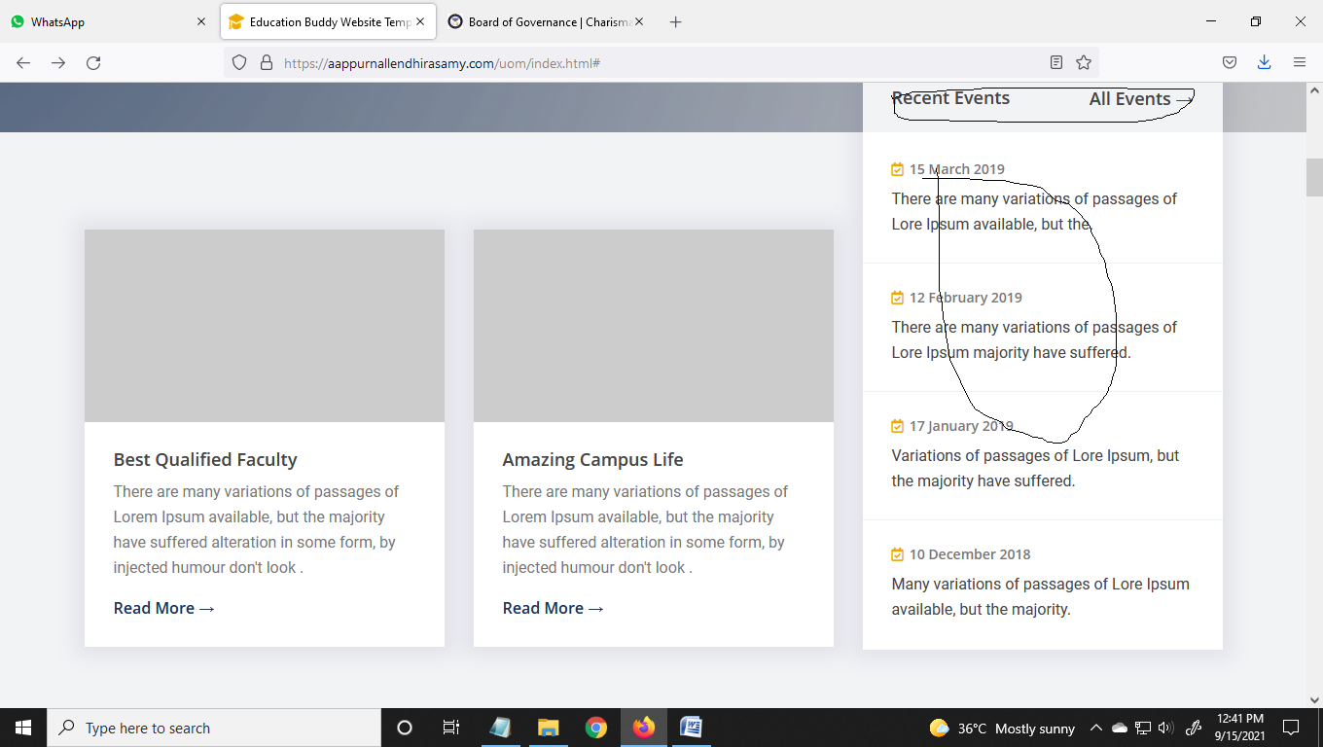

**University Policies**

Disability Policy

Affirmative Action Policy

Sexual Harassment and Sexual Discrimination

Ethical Computer Use

Copyright Policy and Procedure

Cyber Bullying

Refund Policy

------------------------------------------------------------------------------------------

**If we click the each pages then its goes to the listed:**

**Disability Policy:**

University of Marlyne is committed to providing an education that does not discriminate and promotes ethical use of the computer technology. The University disability policy has a direct impact on the usage of media, technologies, and materials for online learning courses, especially with respect to our hard of hearing and deaf students. All online course media and materials with an audio component are either transcribed or captioned before we assign them (usually before the classes start) to provide practical accommodation for hard of hearing and deaf students. Since instructors may not know whether they have a hard of hearing or deaf students enrolled in their class until the end of the drop/add period, they are required to choose and develop accessible materials when they design their courses. Reasonable accommodations for students with hearing disabilities currently do not exist when instructors use synchronous audio communication technologies within a course. For example, we do not use online learning telephone conferencing systems when students with hearing disabilities are registered in a course, even when the participation of the student is not needed.

**Affirmative Action Policy:**

University of Marlyne recognizes the need for affirmative action and pledges its commitment to take on positive actions to address the effects of past practices or barriers to equal education opportunity and also to achieve the fair and full participation of people with disabilities, women, minorities, and older persons. The University also further states that it will conform to the anti-discrimination provisions of the federal regulations and laws. We recognize the education difficulties experienced by minorities, people with disabilities and by many older persons and, where appropriate, we have set program goals to overcome the present effects of past discrimination, if any, to achieve the full and fair teaching and learning of such persons. In order to implement affirmative action policies, our staff has prepared an affirmative action plan that includes programs aimed at eliminating discrimination and promoting fairness. The affirmative action plan incorporates specific objectives, goals, actions, timetables, as well as a complaint procedure.

**Sexual Harassment & Gender Discrimination:**

Unwelcome sexual advances, requests for sexual favors, and other verbal or physical conduct of a sexual nature constitutes sexual harassment when submission to or rejection of this conduct explicitly or implicitly affects an individual’s employment, unreasonably interferes with an individual’s work performance or creates an “intimidating, hostile or offensive work environment.” University of Marlyne has zero tolerance on sexual harassment from any staff, faculty members, and or students. Appropriate law enforcement agencies must be notified in the event the University believes that sexual harassment has occurred.

**Ethical Computer Use:**

University of Marlyne upholds ethical computer use. Everyone within the community who uses the University communications and computing facilities is responsible to use them in a professional, legal, and ethical manner. This means that every user agrees to the following conditions: Users must respect the integrity of the systems and must recognize that some data are confidential. They must also respect the rules and regulations that govern the use of equipment and facilities and they must not obtain unauthorized access to the accounts and files of others. Users must also respect the intended use of all accounts and they must follow the guidelines for and familiarize themselves with appropriate usage for the systems they access.

**Copyright Policy and Procedures:**

University of Marlyne has a strict policy regarding copyrights and patents. Any student who makes a research project which involves significant use of facilities, equipment, funds, or materials of the University, or one that is subject to terms and conditions of a sponsored project or other contract between the University and another party shall assign this project as well as all its patents and applications to the University, unless the project has been released to the researcher in accordance with the patent policy provisions.

When a student completes a research project that does not involve significant use of facilities, equipment, funds, or materials of this University, and one that is not under the terms of a sponsored research project or other contract between the University and another party, the University will waive its rights and the research project will be the exclusive property of the student, provided that his or her rights in the project are not changed by the terms of financial aid received, such as scholarships, external sponsorship, traineeships, fellowships, or any other financial aid, whether or not the project is administered by the University.

The Dean of Students Affairs is the one responsible for administering intellectual property matters that are related to patents, inventions, trademarks, publications, and copyrights. The Dean of Students Affairs shall represent the University in any matter regarding intellectual property that may substantially affect the institution’s relationships with the public, government, and industry. It is the responsibility of the patent committee to advise and make recommendations to the Dean of Students Affairs relating to intellectual property matters that arise from the activities of the students, conducting research, the determination of rights between the researchers and the University, as well as the disposition of patent rights that the institution does not wish to exercise.

**Cyber Bullying:**

A safe and civil environment is necessary for students to be successful in their educational pursuits. Cyber-bullying or cyber harassment by any member of the University of Marlyne community (student, faculty, staff, etc.) toward another individual constitutes conduct that disrupts the educational environment of the University. Examples of cyber-bullying and cyber harassment include, but are not limited to, harsh text messages or emails, rumors sent by email or posted on social networking sites, and embarrassing pictures, videos, websites, or fake profiles.

Cyber-bullying and cyber harassment are prohibited by many state laws, by various federal laws, and many jurisdictions throughout the international community.

University of Marlyne will not tolerate lewd, intimidating or other disorderly conduct by or toward members of its community. The following are examples of instances where social media can cause harm to the University or a member of the University of Marlyne community or may violate policies:

A University of Marlyne student establishes a Twitter account that encourages others to submit negative anonymous messages to an account that will be redistributed by the account holder.

A member of the University community establishes a fake account under the name of an official University official or department and uses the name and trademark to post vicious comments or other content.

A member of the University faculty or staff uses his or her blog or social media account to berate or otherwise discuss engagement with or judgment of a student’s work or other information considered confidential or proprietary by FERPA or HIPPA.

Cyber-bullying and cyber harassment are direct violations of several standards of the University of Marlyne standard of conduct. The Code prohibits acts of cyber-bullying or cyber harassment through the use of any electronic technology, which includes, but is not limited to, devices and equipment such as cell phones, computers and tablets as well as communication tools, including, but not limited to, text messages, chat platforms, websites and social media sites like Twitter, Facebook, Instagram, YouTube, Bebo, and blogs. Students who use University networks or technology to conduct such activity may be disciplined in accordance with University of Marlyne’s standard of conduct.

All other members of the University community are likewise prohibited from engaging in cyber-bullying or cyber harassment, and instances will be adjudicated through the proper established channels.

Students who feel that they are being bullied or harassed through electronic technology should immediately report it to the office of the University.

------------------------------------------------------------------------------------------